Content 46

Function File I/O in C

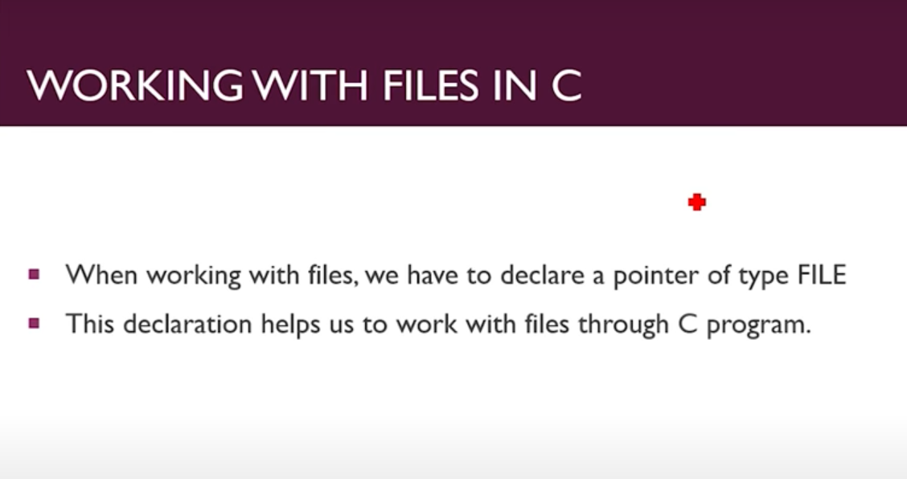

#### Modes:

Before discussing Files' functions, we have to learn about different modes used along with these functions as a parameter. The following are the modes:

* **r**: opens a file for reading.
* **w**: opens a file for writing. It can also create a new file.
* **a**: opens a file for appending.
* **r+**: opens a file for both reading and writing but cannot create a new file.
* **w+**: opens a file for both reading and writing.

Note: there are many other modes, but these are the basic and most used ones.

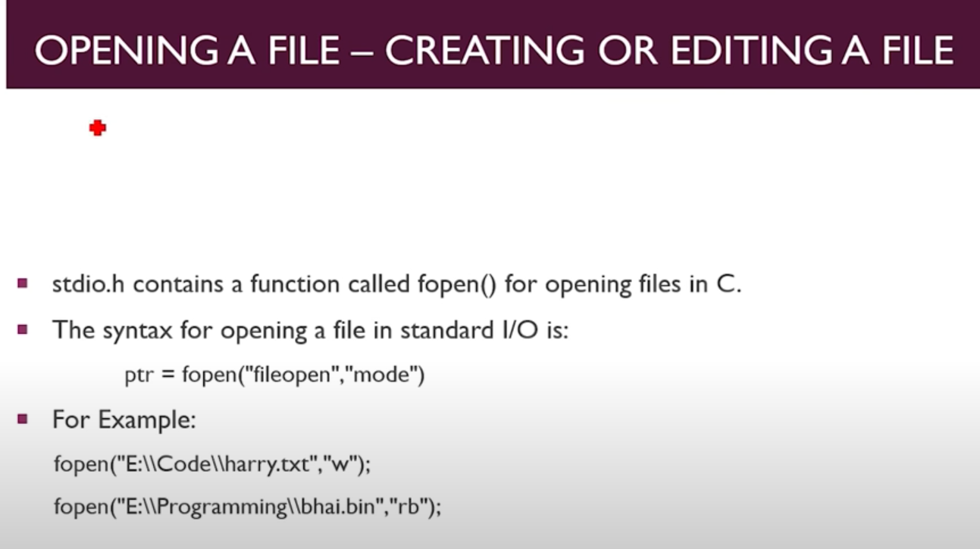

#### Opening a File:

We use the fopen() function for opening files in C.

**Syntax:**

ptr = fopen(“file_location”,”mode”);

**Example:**

ptr = fopen(“D:\\file.txt”,”w”);

#### Closing a File:

Closing an open file is one of the most crucial steps while dealing with C. Files does not automatically get closed after working with them. We have to close them manually. To close a file, we have to use the **fclose()** function. The syntax is straightforward because we just have to send the pointer as a parameter to the function.

**Syntax:**

fclose(fptr);

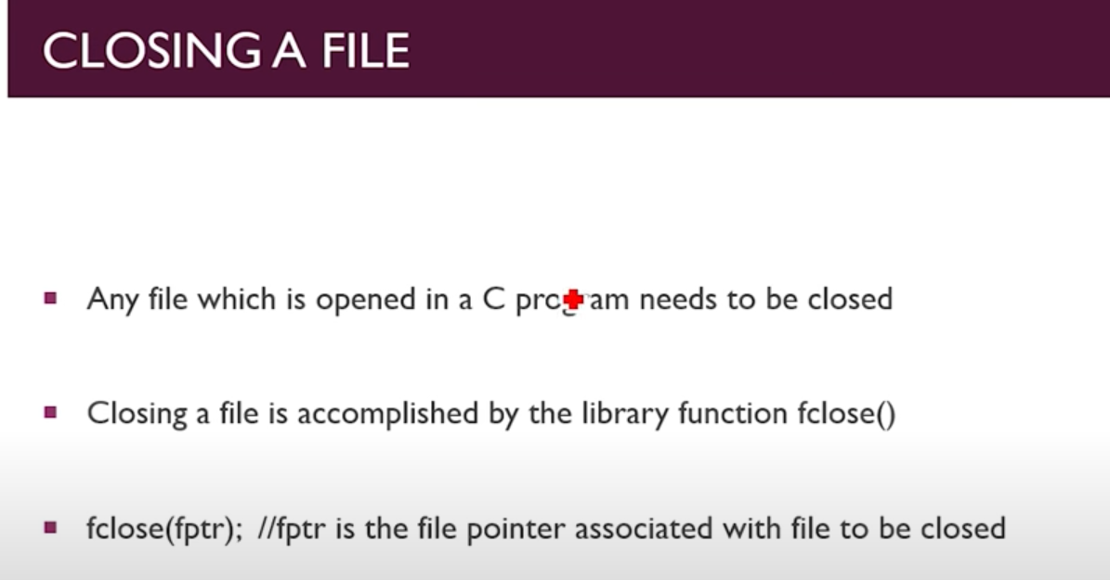

#### Reading a File:

To read a file in C, we use a function fscanf(). This function is a file version of**scanf()**. Like scanf() used to get input from the keyboard, it gets its input from a file and prints it onto the screen. We have to send the file pointer as an argument for the program to be able to read it. The file has to be opened in r mode, i.e., read mode, to work properly for fsanf().

**Example:**

#include <stdio.h>

int main()

{

    //********reading a file******

    FILE *ptr=NULL;

    char string[20];

    ptr = fopen("main.txt", "r");

    fscanf(ptr, "%s",string);

    printf("The Content of the file before is: %s",string);

    return 0;

}

**And My Text File (main.txt):**  And from this I am reading the ontent.

This_is_My File.

This for Sample Purpose.

**Output:**

The Content of the file before is: This_is_My

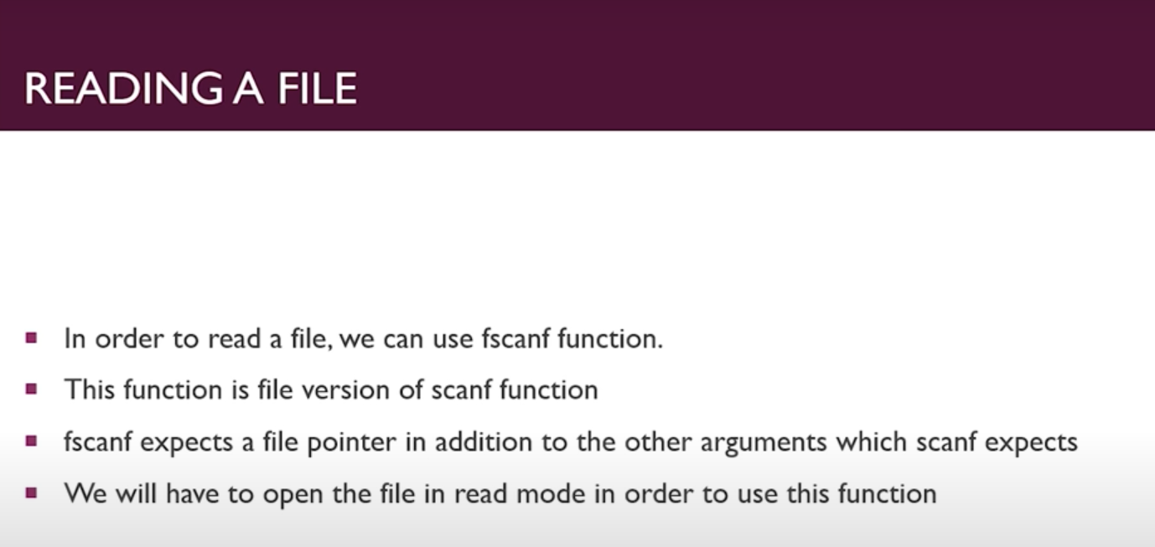

#### Writing to a file:

In order to write to a file, we use the function **fprintf()**. The function is a file version of printf(). Same as we used to print text onto the screen using printf(), we use fprintf() to print text inside the file. We have to send the file pointer as an argument for the program to be able to print it into the file. The file has to be opened in w mode, i.e. write mode, to work properly for fsanf().

**Example: Before my file is like this:**

This_is_My File.

This for Sample Purpose.

**Code:**

#include <stdio.h>

int main()

{

     // //********writing a file******

    FILE *ptr=NULL;

    char string[20]="My phone gets Broke";

    ptr = fopen("main.txt", "w");

    fprintf(ptr, "%s",string);

    return 0;

}

After After Execution I got this as my file:

My phone gets Broke

So Here my first content got Erase.

But If I open it by append mode I Will get my content added in it.

**Using Append Mode:**

Here my file Before;

This_is_My File.

This for Sample Purpose.

**Code:**

#include <stdio.h>

int main()

{

       // //********open by append mode******

    FILE *ptr=NULL;

    char string[20]="My phone gets Broke";

    ptr = fopen("main.txt", "a");

    fprintf(ptr, "%s ",string);

    return 0;

}

**After using Append Mode My file becomes:**

This_is_My File.

This for Sample Purpose.

My phone gets Broke

**Here addition takes place, First Content not get Erased.**

#### C:\Users\Aamaan Satvilkar\AppData\Local\Microsoft\Windows\INetCache\Content.Word\Screenshot (61).png

#### Summary:

In this tutorial we saw different modes of opening files and how to open, close, read or write to a file, along with their syntax and implementation. In the nest tutorial we will see additional functions such as **fget, fput, fgetc and fputc**

**Code for I/O some operations with c:**

#include <stdio.h>

int main()

{

    // //********reading a file******

    // FILE *ptr=NULL;

    // char string[20];

    // ptr = fopen("main.txt", "r");

    // fscanf(ptr, "%s",string);

    // printf("The Content of the file before is: %s",string);

     // //********writing a file******

    // FILE *ptr=NULL;

    // char string[20]="My phone gets Broke";

    // ptr = fopen("main.txt", "w");

    // fprintf(ptr, "%s",string);

       // //********open by append mode******

    FILE *ptr=NULL;

    char string[20]="My phone gets Broke";

    ptr = fopen("main.txt", "a");

    fprintf(ptr, "%s ",string);

    return 0;

}